Description of Project
Chronic disease such as diabetes, chronic obstructive pulmonary disease (COPD), coronary heart disease, stroke, and kidney disease continues to be major causes of illness and healthcare utilization in the United States. Understanding the relationship between chronic disease prevalence, population demographics, socioeconomic factors, and healthcare provider availability can provide insight into potential gaps in access to care and support more informed healthcare planning.
The objective of this project is to examine chronic disease prevalence and explore how demographic characteristics, socioeconomic status, and healthcare provider availability may influence healthcare outcomes. To support this objective, three publicly available healthcare datasets were analyzed. The Behavioral Risk Factor Surveillance System (BRFSS) dataset was used to examine the prevalence of chronic diseases across different population groups (Centers for Disease Control and Prevention, 2024). The National Health and Nutrition Examination Survey (NHANES) dataset was used to evaluate demographic and socioeconomic characteristics, including age, race/ethnicity, and Income-to-Poverty ratios (Centers for Disease and Prevention, National Center for Health Statistics, n.d.). The Centers for Medicare & Medicaid Services (CMS) provider dataset was used to assess the availability of healthcare providers associated with chronic disease treatment (Centers for Medicare and Medicaid Services, 2023).
The analysis focused on chronic diseases including diabetes, COPD, coronary heart disease, stroke, and kidney disease. Within the CMS dataset, the provider analysis was narrowed from 52 medical specialties to those more closely associated with chronic disease management including Cardiology, Pulmonary Disease, Neurology, Endocrinology, Gastroenterology, Hematology-Oncology, and Urology. Narrowing the provider specialties created a closer connection between the CMS data and the chronic conditions evaluated in the BRFSS dataset.
Exploratory data analysis methods were used to identify patterns, trends, and relationships across datasets. Correlation analysis, demographic comparisons, socioeconomic evaluations, and provider workforce trends were examined to better understand how chronic disease prevalence relates to population characteristics and healthcare provider availability. The findings from this analysis provide a broader view of population health needs and may help determine whether healthcare provider availability aligns with populations affected by chronic disease.
Exploratory Data Analysis
Exploratory data analysis was performed on the BRFSS, NHANES, and CMS datasets to better understand the quality, structure, distributions, and relationships. The process included preprocessing to prepare each dataset, univariate analysis to examine individual variables, and bivariate analysis to identify relationships between variables. These steps helped determine which variables were most relevant to the project and whether the datasets were adequate for analyzing chronic disease prevalence, demographic and socioeconomic characteristics, and healthcare provider availability.
Data Preprocessing
Data preprocessing began by reviewing each dataset for missing values, duplicate records, data types, and variables relevant to the project’s focus. Since each dataset contained much more information than what was required to support the project, preprocessing also involved narrowing the data to variables that supported the overall research objective. This was important because the three datasets served different purposes with the project. BRFSS provided information about chronic disease prevalence, NHANES provided demographic and socioeconomic information, and CMS provided healthcare provider counts.
The BRFSS dataset contained many health, demographic, and behavioral variables. The initial review included diabetes, COPD, coronary heart disease, heart attack, stroke, kidney disease, and arthritis. Demographic and health related variables such as age, sex, income, and general health status were also considered because they could provide additional insight for differences in chronic disease prevalence. Many BRFSS variables were represented by numerical category codes rather than continuous measurements, requiring the codes to be interpreted correctly before any analysis and visualizations could be completed. Arthritis was initially considered but removed so that the analysis could focus on chronic conditions that could be more closely aligned to healthcare specialties represented in the CMS dataset.
NHANES added demographic and socioeconomic factors to the analysis. The dataset contained 11,933 respondents and 27 variables and was reviewed for missing values, duplicate records, and variable relevance. No duplicate records were identified, although there were several variables which contained missing values. This occurred because certain questions were only applicable to specific groups of respondents. The initial review included variables related to age, gender, race/ethnicity, education, marital status, pregnancy status, household size, and socioeconomic characteristics. The analysis was narrowed to age, gender, race/ethnicity, and income-to-poverty ratio because these variables provided the strongest connection to the project’s objective. Variables such as pregnancy status, marital status, and household characteristics were excluded because they either did not apply to the entire population or provided less support for the analysis.
The income-to-poverty ratio became important because it provided a consistent measure for comparing socioeconomic differences across population groups. The variable represents household income relative to the federal poverty level and has a maximum value of 5.0. Since the distribution was not normally distributed, the median income to poverty ratio was used when comparing age and race/ethnicity groups. The median provided a more consistent representation of the typical respondent and was less influenced by higher values.
The CMS dataset provided information about healthcare provider availability and initially contained 96 provider specialties with annual provider counts from 2019 through 2023. The data was reviewed for missing values, duplicates, and data type issues. No duplicate records were identified, and only a small number of values were missing. The 2019 provider count field required additional preprocessing because a non-numeric value caused the field to be stored as text. The field was converted into a numeric data type so that 2019 could be analyzed consistently with the remaining years. The dataset was then narrowed from 96 provider specialties to 52 medical specialties and further reduced to those most closely associated with chronic disease management. The final analysis focused on Cardiology, Pulmonary Disease, Neurology, Nephrology, Endocrinology, Gastroenterology, Hematology-Oncology, and Urology. Specialties such as Emergency Medicine were excluded because they did not align directly with the chronic diseases reviewed in the project. These preprocessing steps improved the consistency of the CMS dataset while keeping the provider analysis focused on specialties most relevant to the project.
Univariate Analysis
Univariate analysis was used to examine individual variables within each dataset before evaluating relationships between variables. This analysis provided a better understanding of the distributions, ranges, and overall characteristics of the data. Histograms, bar charts, and descriptive statistics such as mean, median, mode, minimum, and maximum were used where appropriate. The results also helped to identify skewed distributions and determine which variables would be most useful for the next stages of analysis.
The BRFSS analysis focused on the prevalence of chronic diseases, including diabetes, COPD, coronary heart disease, heart attack, stroke, and kidney disease. The analysis showed differences in prevalence across chronic diseases examined, with diabetes having the highest prevalence among the conditions. Examining each condition individually helped to establish which diseases were more common within the BRFSS population before demographic characteristics were introduced to the analysis. These findings also supported the decision to continue examining diabetes more closely. Other chronic conditions remained important because they provided a broader view of chronic disease prevalence and could be connected to the medical specialties examined in the CMS dataset.
The NHANES univariate analysis centered on age, race/ethnicity, and income-to-poverty ratio. Respondents represented a wide range of ages and racial/ethnic groups, providing useful demographic information. The income-to-poverty ratio varied considerably across respondents and had a maximum recorded value of 5.0. The distribution was not normal, so the median rather than the mean was used to represent the typical income-to-poverty ratio across demographic groups. The median was less influenced by higher values and provided a consistent measure for interpreting socioeconomic characteristics with the NHANES population.
Univariate analysis on the CMS dataset provided further insight into differences in healthcare provider availability. Provider counts varied across medical specialties, with some specialties having much larger provider populations than others. The original distribution of provider counts was right skewed because a smaller number of specialties had much higher provider counts than the majority of specialties. A logarithmic transformation was applied to make the distribution easier to visualize and reduce the effect of the largest provider counts. After the dataset was narrowed to specialties associated with chronic disease care, Cardiology had the largest provider workforce among the selected specialties, while Endocrinology had the smallest. The differences showed that the number of providers available for chronic disease care varied considerably depending on the medical specialty.
Bivariate Analysis
The BRFSS correlation analysis showed generally weak relationships among the chronic disease and demographic variables examined. One of the more meaningful relationships involved age and diabetes. Although the correlation between the original coded Age Group and Diabetes was weak, examining diabetes prevalence across age groups showed a much clearer pattern. The percentage of respondents reporting diabetes increased steadily from the younger age groups through older adulthood with a much higher prevalence among older respondents. The scatterplot and regression line also revealed an upward trend in diabetes prevalence as age increased. The findings suggest that age is an important factor associated with diabetes prevalence.
A correlation matrix was used with the NHANES dataset, and it revealed weak relationships among age, gender, race/ethnicity, and income to poverty ratio. The strongest correlation was between age and income-to-poverty (r=.16), which represents a weak positive relationship. However, comparing median income-to-poverty ratios across demographic groups showed patterns that were not as apparent from the correlation matrix. Median income-to-poverty ratio slightly increased from childhood through middle adulthood before decreasing among older adults. Differences were also observed across racial and ethnic group, with Non-Hispanic White respondents having higher median income-to-poverty ratios than Non-Hispanic Black, Mexican American, and Other Hispanic respondents. When age and race/ethnicity were examined together, the results showed that socioeconomic differences varied among population groups and could not be explained by age alone. The correlation results for race/ethnicity were examined carefully because the numbers represent different groups rather than actual numerical values.
The CMS correlation analysis showed extremely strong positive relationships between provider counts from 2019 through 2023, with correlations ranging from approximately 0.99 to 1.00. These high correlations were expected because the same medical specialties were measured across consecutive years. The results indicate that specialties with larger provider workforces remained larger throughout the five-year period, while specialties with smaller provider workforces remained smaller. The high correlation does not mean that provider counts remained unchanged, but rather that the overall pattern among specialties remained consistent.
The provider trend analysis offered a clearer view of how individual specialties changed over time. Cardiology consistently maintained the largest provider workforce among the chronic disease specialties reviewed, while Endocrinology remained the smallest provider. Neurology and Gastroenterology revealed gradual increases from 2019 through 2023, while the other specialties experienced smaller changes. Overall, provider counts remained quite stable, with no major increases or decreases from year to year. The differences between specialties remained noticeable over the five-year period, showing that some areas of chronic disease care consistently had larger provider workforces than others. This pattern also shows that changes in provider availability occurred gradually rather than shifting significantly from one year to the next. These findings suggest that differences in provider availability across chronic disease specialties stayed consistent throughout the five-year period.
Conclusions
Expected/Unexpected Data
The exploratory analysis identified several patterns in the BRFSS, NHANES, and CMS datasets that were consistent with expectations. In the BRFSS dataset, chronic disease cases were concentrated more among older age groups than younger age groups, as shown in Figure 1. Diabetes, COPD, heart attack, and kidney disease all showed higher case counts with older respondents as compared to those that were younger. Figure 2 further demonstrates this age-related pattern by showing that diabetes prevalence generally increased as age increased. This finding indicates that age is an important factor associated with diabetes and was consistent with expectations because diabetes is more frequently reported among older adults. Together, the BRFSS figures show a clear view of age-related patterns in the BRFSS dataset.
The NHANES analysis provided additional information about demographic and socioeconomic differences. The correlation matrix in figure 3 showed weak relationships among age, gender, race/ethnicity, and income to poverty ratio, with the strongest relationship between age and income to poverty (r=0.16). Overall, the correlation matrix analysis did not identify any strong relationships among the selected variables. However, more meaningful patterns became visible when median income-to-poverty ratios were compared over the various demographic groups. Figure 4 shows differences in median income to poverty across racial and ethnic groups, while Figure 5 adds age group to show how these differences changed across the population. Median income-to-poverty increased through young adults before slightly declining among older adults. Non-Hispanic White respondents had higher median income-to-poverty ratios than Non-Hispanic Black, Mexican American, and Other Hispanic respondents. The combined age and race/ethnicity analysis showed that socioeconomic differences were present across multiple age groups rather than being explained by age alone. These findings were consistent with expectations and showed that comparing demographic groups provided information that was not as visible from the correlation matrix alone.
The CMS results showed noticeable differences in provider availability across the chronic disease specialties examined. As shown in Figure 6, provider counts changed gradually from 2019 through 2023. Neurology and Gastroenterology experienced gradual increases in provider counts, while Cardiology continued to have the largest provider workforce despite a slight decline. Figure 7 provides a clearer comparison of the provider workforce in 2023 and highlights the differences in workforce size among the selected specialties. The smaller Endocrinology workforce was especially noteworthy because diabetes had the highest prevalence among the chronic diseases examined in the BRFSS analysis. Though, the results do not necessarily indicate that there are too few Endocrinology providers. Provider availability may also be influenced by factors such as population size, patient demand, provider location, and the role of primary care providers managing diabetes.
Disqualified Data
There was no dataset that was entirely removed because of challenges identified during the exploratory analysis. Instead, individual variables and categories were removed or adjusted when they did not align with the objective of the project. For example, arthritis was initially evaluated in the BRFSS but was removed from the focused chronic disease analysis. Removing arthritis allowed the analysis to focus on chronic conditions that were more directly connected to healthcare specialties in the CMS dataset, creating a stronger connection between chronic disease prevalence and provider availability.
Within NHANES, variables such as pregnancy status, marital status, and certain household characteristics were evaluated but not included because they either applied only to specific respondents or provided less direct support for the research objective. Some NHANES variables also contained substantial amounts of missing data because related questions were only asked of certain respondents. Rather than treating these missing values as evidence that the dataset was unusable, the analysis focused on age, gender, race/ethnicity, and income-to-poverty ratio, which provided broader demographic and socioeconomic information across the population. This approach allowed the NHANES dataset to remain useful while limiting the analysis to variables that were more consistently available and relevant to the project.
For CMS, the provider specialties were narrowed from the original 96 specialties to 52 medical specialties and then to specialties most closely associated with chronic disease management. Specialties with less direct relevance, such as Emergency Medicine, were excluded from the analysis. The 2019 provider count variable also required conversion from text to a numeric format before it could be analyzed with the other years. Narrowing the specialties strengthened the connection between the CMS provider data and the chronic diseases evaluated in BRFSS.
Supervised/Unsupervised Analysis
The findings from the exploratory analysis also suggest opportunities for additional supervised and unsupervised analysis. A logistic regression model could use BRFSS characteristics such as age, income, sex, general health, and other variables are associated with whether a respondent reports having diabetes. This approach would build on the age-related pattern identified in the BRFSS analysis, where diabetes prevalence increased among older age groups. Logistic regression would be appropriate because diabetes status can be shown as a binary outcome, such as whether a respondent reported having diabetes or not. The model could examine several characteristics at the same time and help identify which factors have the strongest relationship with diabetes. Other supervised models, such as decision tree or random forest, could be considered. These models would allow more complex relationships among demographic and health characteristics to be analyzed. For example, age by itself may be useful, but age combined with income and general health may provide additional insight into an individual's likelihood of reporting diabetes. A random forest could also help identify which variables are most useful when classifying respondents based on diabetes status. Comparing these models with logistic regression could help in determining whether a more simple or complex statistical model provides better results.
The data could also be explored using an unsupervised method such as K-means clustering. Unlike supervised analysis, clustering would not begin with a predefined outcome such as diabetes status. As an alternative, respondents could be grouped based on similarities in characteristics such as age, income-to-poverty, general health, and selected chronic disease indicators. This approach could help identify population segments with similar demographic, socioeconomic, and health profiles and determine whether certain segments have higher levels of chronic disease or different healthcare needs. Since age and income-to-poverty are measured on different numerical scales, the variables would need to be standardized before using K-means so that one variable does not have a greater influence because its values are larger. Hierarchical clustering could also be considered as another method for identifying groups with similar characteristics. Utilizing these methods could further the exploratory analysis by identifying population patterns that may not be as clear when examining individual variables and relationships between only two variables. Overall, the three datasets provide complementary perspectives on the research objective. BRFSS identifies chronic disease patterns and demonstrates the importance of age in diabetes prevalence. NHANES adds demographic and socioeconomic context, while CMS shows how provider availability differs among chronic disease specialties and changes over time. Considered together, the findings provide a foundation for evaluating how chronic disease prevalence, population characteristics, and healthcare resources may relate to one another.

Figures
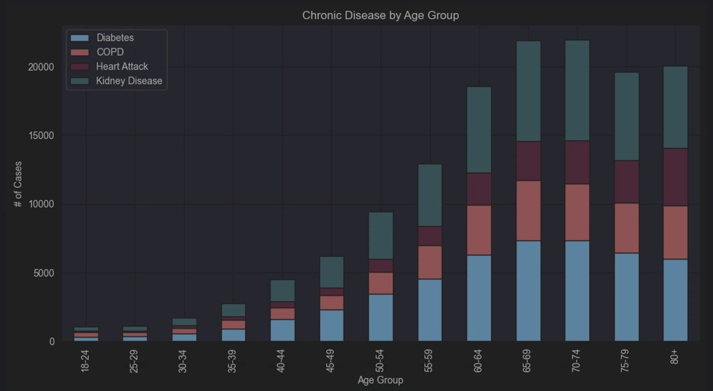  Figure 1. Reported Chronic Disease Cases by Age Group | 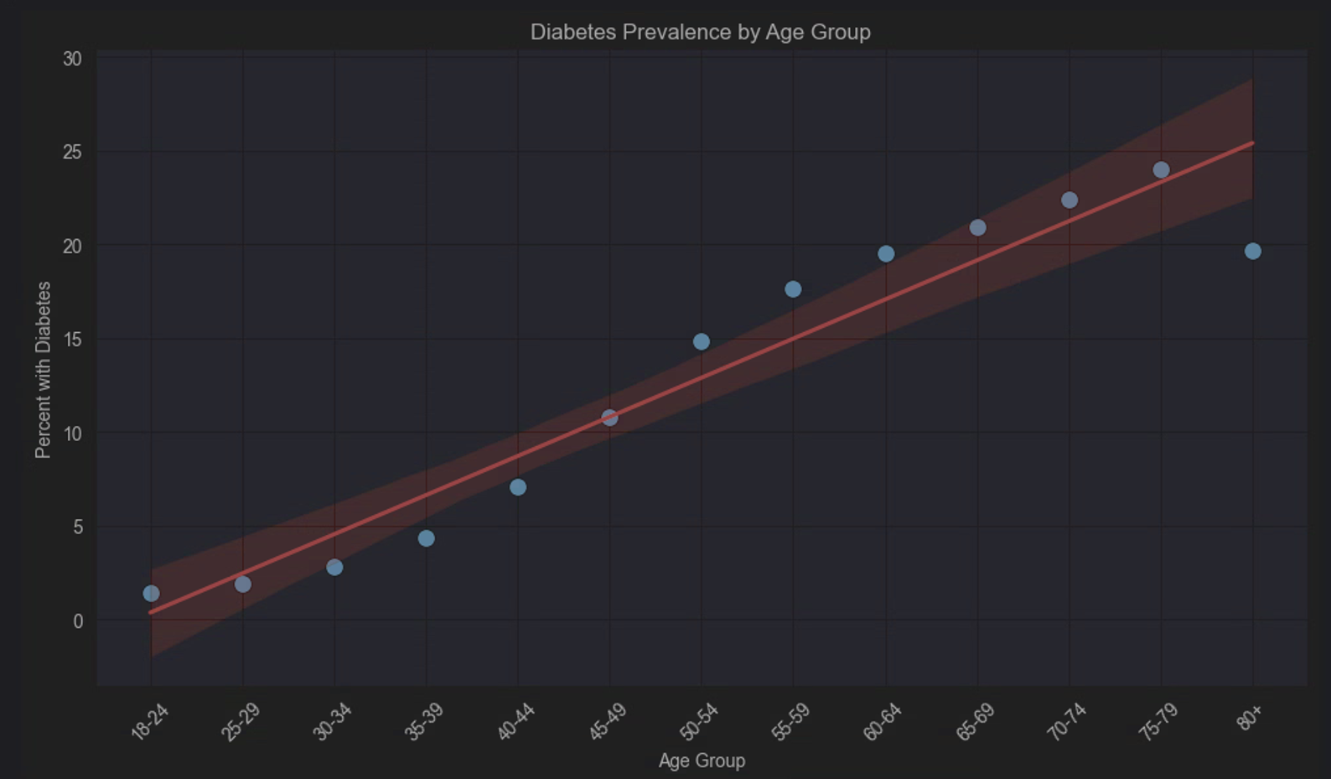  Figure 2. Diabetes Prevalence by Age Group
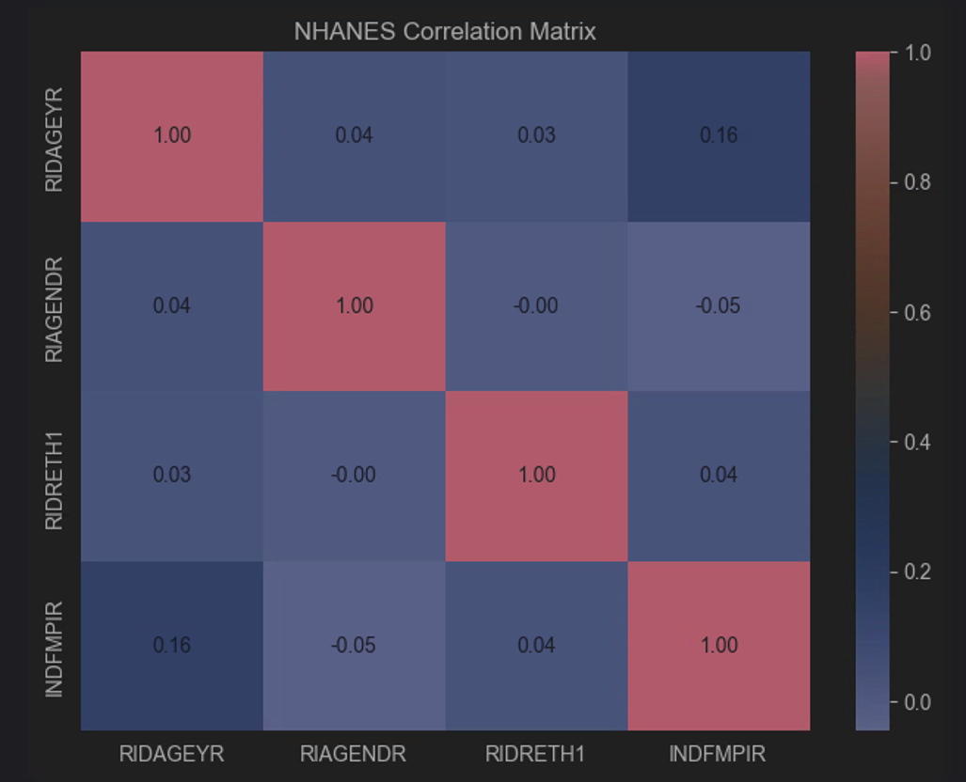 Figure 3. NHANES Correlation Matrix | 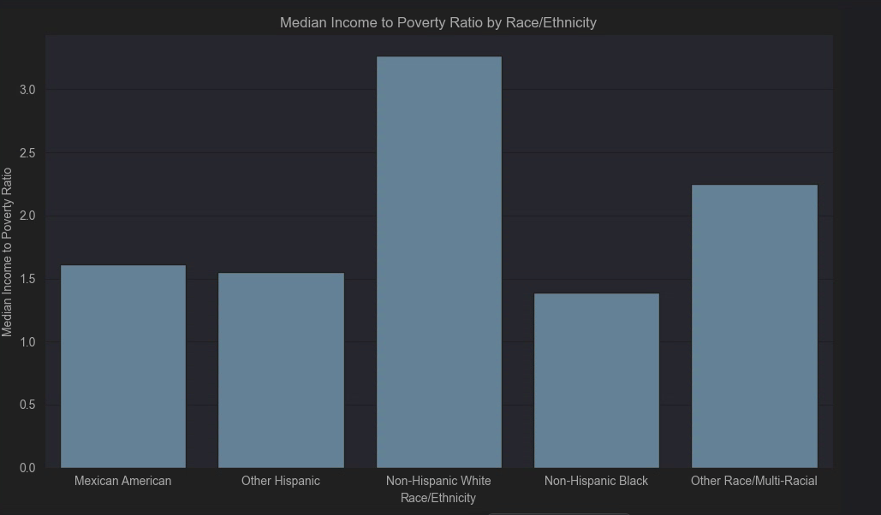  Figure 4. Median Income-to-Poverty Ratio by Race/Ethnicity
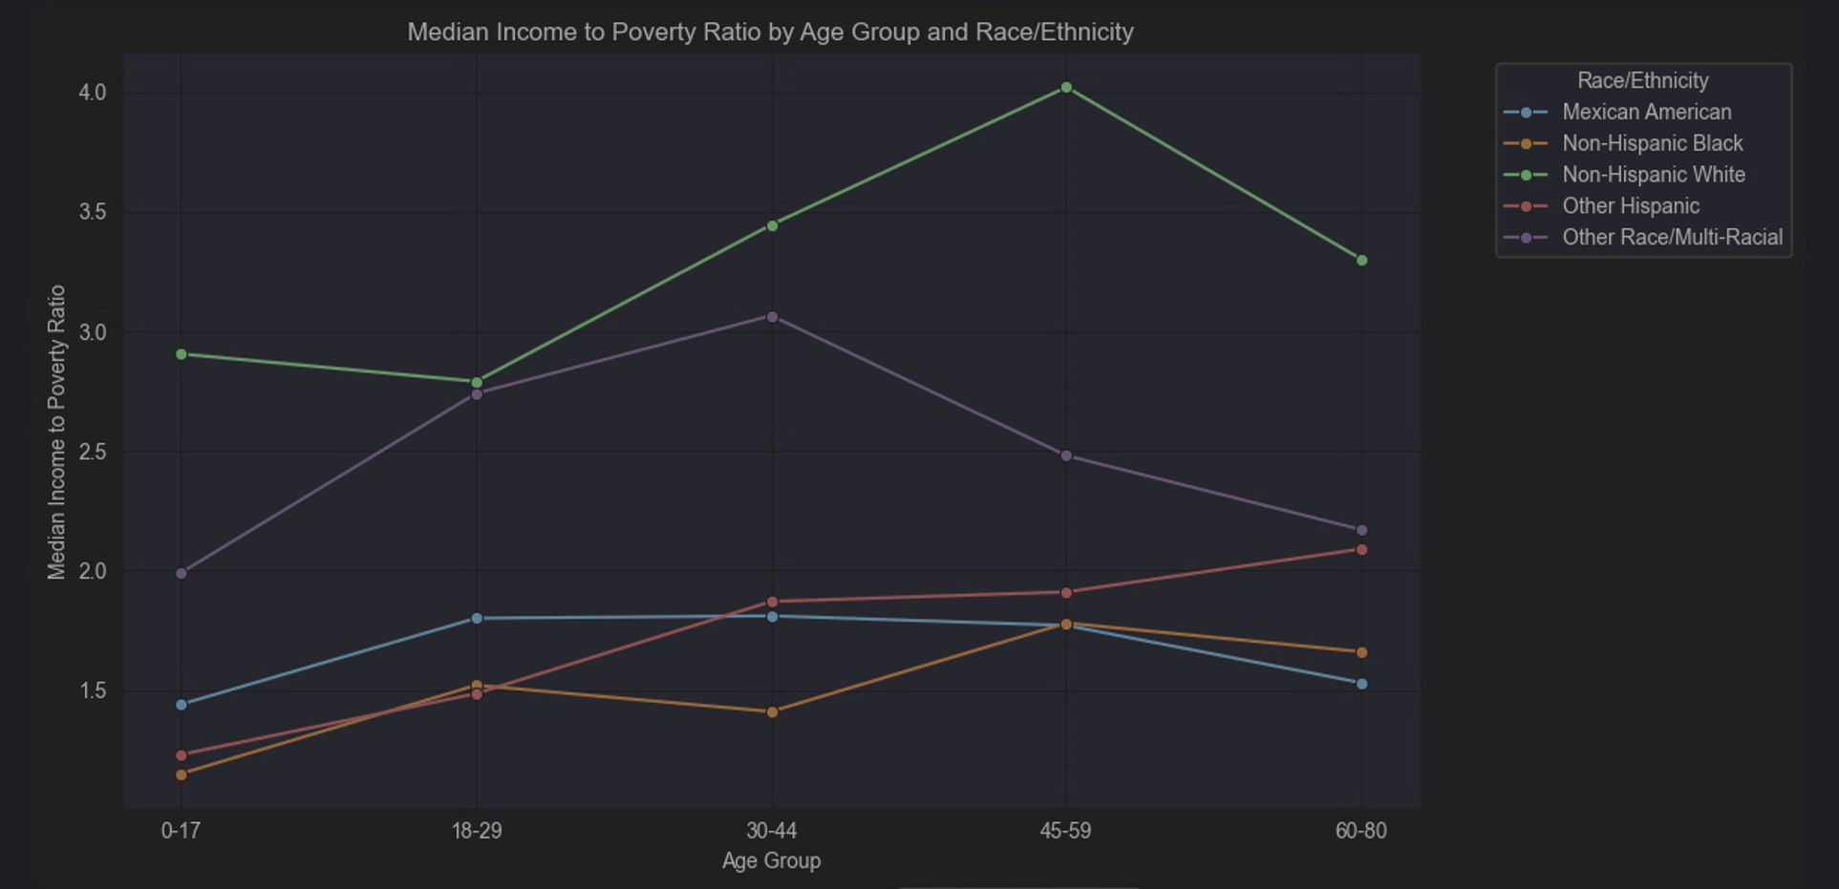  Figure 5. Median Income-to-Poverty Ratio by Age Group and Race/Ethnicity | 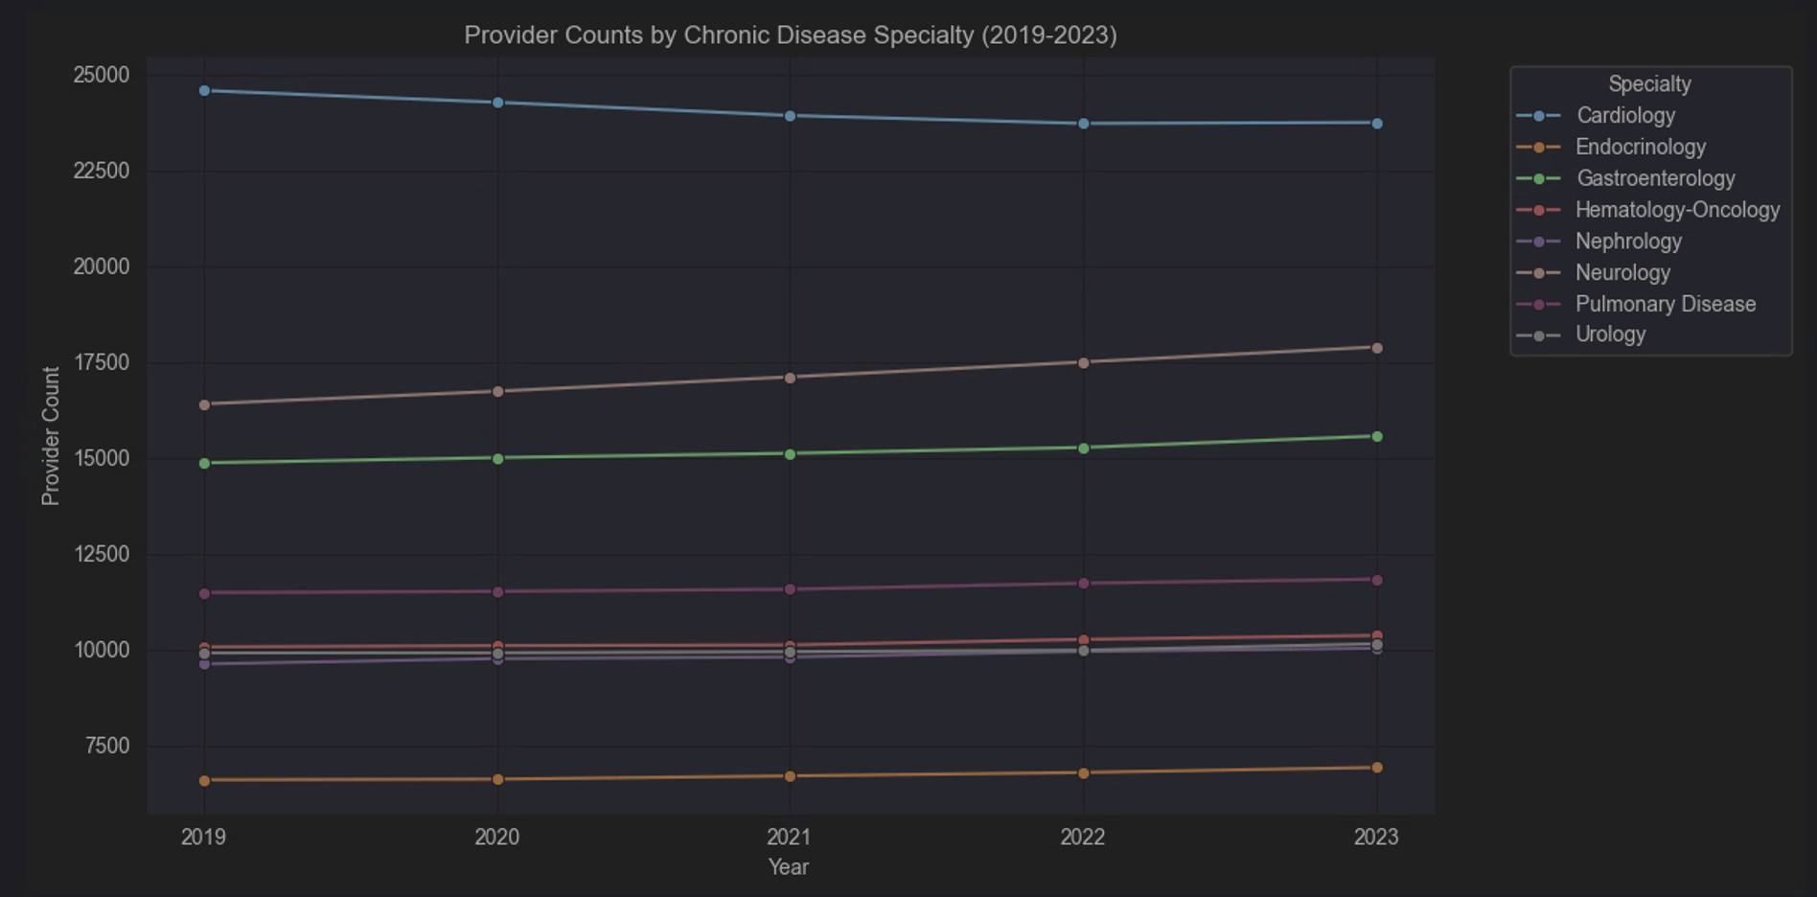  Figure 6. Provider Counts by Chronic Disease Specialty (2019–2023)

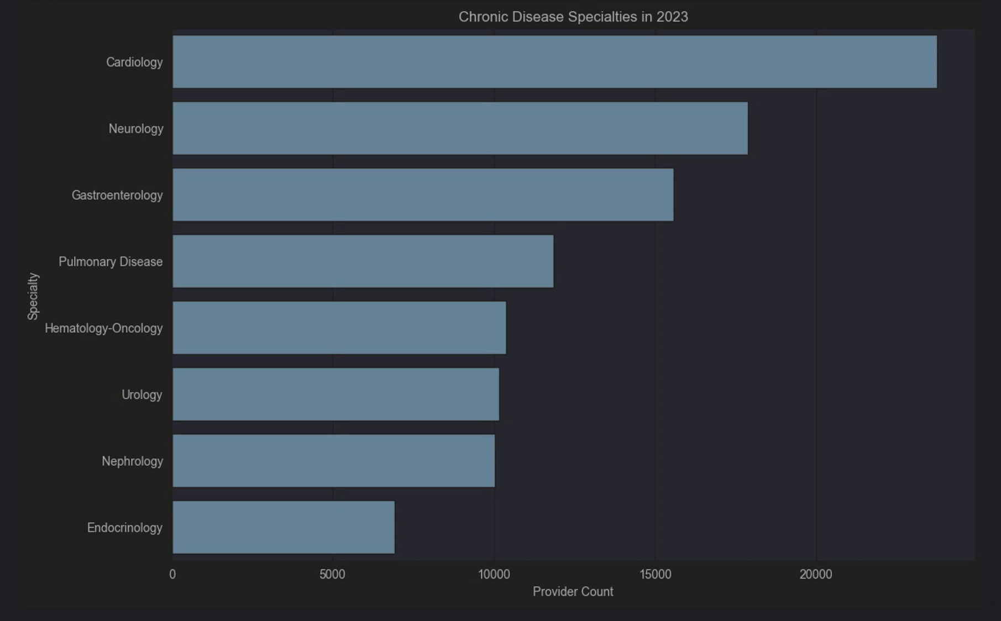
Figure 7. Chronic Disease Specialties in 2023

Appendix

Citations
Centers for Disease Control and Prevention. (2024). Behavioral Risk Factor Surveillance System: 2024 BRFSS survey data and documentation. https://www.cdc.gov/brfss/annual_data/2024/files/LLCP2024XPT.zip
Centers for Disease Control and Prevention, National Center for Health Statistics. (n.d.). National Health and Nutrition Examination Survey. https://wwwn.cdc.gov/Nchs/Data/Nhanes/Public/2021/DataFiles/DEMO_L.xpt
Centers for Medicare & Medicaid Services. (2023). CMS program statistics: Medicare providers. https://data.cms.gov/sites/default/files/dataset_zips/204757430e2f7763d197f205c24150c0/CMS%20Program%20Statistics%20-%20Medicare%20Providers.zip

AI Appendix
Prompt in CoPilot:
I have three sets of data I am examining for a capstone project I am working on. I am trying to get a few ideas on the analysis I could potentially do. The data sets are: CDC Behavioral Risk Factor Surveillance System (BRFSS) 2024 - CDC National Health and Nutrition Examination Survey (NHANES) 2021–2023 - CDC/NCHS CMS Program Statistics: Medicare Providers 2023 - Centers for Medicare and Medicaid Services pe-reports/cms-program-statistics-medicare-providers

Copilot said:
Yes. Given the three datasets you have, you actually have the pieces for a strong capstone because they let you examine the healthcare story from three different perspectives:
- BRFSS 2024 → chronic disease prevalence and behavioral risk at the population level
- NHANES 2021–2023 → demographic and socioeconomic characteristics of the population
- CMS Medicare Providers 2023 → availability/distribution of healthcare providers
The strongest approach is not necessarily to force the datasets into one merged dataset. Instead, I would use them to answer related questions around one central theme:
How do chronic disease patterns, demographic and socioeconomic characteristics, and healthcare provider availability help describe potential differences in healthcare needs across the U.S.?
1. BRFSS: Chronic disease burden
This should probably remain the foundation of the analysis.
Some analyses you could do:
Chronic disease prevalence by age
- Diabetes by age group
- COPD by age group
- Coronary heart disease by age group
- Heart attack by age group
- Stroke by age group
- Kidney disease by age group
This could answer:
Which age groups show the greatest chronic disease burden?
Compare diseases within age groups
Rather than looking at each condition separately, compare multiple conditions on the same chart.
For example:
Age group | Diabetes | COPD | CHD | Stroke | Kidney disease
18–24 | ... | ... | ... | ... | ...
25–34 | ... | ... | ... | ... | ...
35–44 | ... | ... | ... | ... | ...
This gives you a nice population-health story about how the mix of conditions changes with age.
Disease relationships
You could also examine whether certain chronic conditions tend to occur together using correlations or cross-tabulations.
For example:
- Diabetes vs. coronary heart disease
- Diabetes vs. kidney disease
- COPD vs. coronary heart disease
I would treat this as exploratory rather than claiming one disease causes another.

2. NHANES: Socioeconomic and demographic patterns
NHANES can give the project a socioeconomic dimension that BRFSS alone doesn't provide.
Since you've already been working with variables such as age, race/ethnicity, and Income-to-Poverty Ratio (INDFMPIR), I think there are several useful directions.
Income-to-poverty ratio by age
Ask:
Are there differences in economic circumstances across age groups?
You could compare median INDFMPIR across age groups.
Income-to-poverty ratio by race/ethnicity
This can show whether the socioeconomic characteristics of the NHANES population differ across demographic groups.
Your previous idea of using:
- Median Income-to-Poverty Ratio by Race/Ethnicity
- Median Income-to-Poverty Ratio by Age Group and Race/Ethnicity
is useful because the second analysis adds another dimension rather than simply repeating the first.
Age and income relationship
You could also explore the relationship between age and INDFMPIR with:
- scatterplot
- correlation
- grouped median analysis
This is particularly useful if you want to demonstrate both bivariate statistical analysis and visualization.

3. CMS: Provider availability
This dataset can provide the healthcare capacity side of your capstone.
For example, focus on specialties that are reasonably connected to the chronic conditions you're examining:
- Cardiology
- Endocrinology
- Nephrology
- Pulmonary Disease
- Neurology
- Gastroenterology
Then examine:
Provider counts by specialty
A straightforward question would be:
How does provider availability differ among specialties associated with chronic disease care?
A sorted bar chart could immediately show which specialties have larger or smaller provider workforces.
Provider trends over time
If you have multiple CMS years, your analysis becomes stronger because you can examine whether provider counts are:
- increasing
- decreasing
- relatively stable
You could calculate percentage change as:
Percentage Change =
((Latest Provider Count - Earliest Provider Count)
/ Earliest Provider Count) × 100
That could help distinguish a specialty that is large but declining from one that is smaller but growing.

An analysis I think would be especially interesting
There is another direction we haven't emphasized as much: compare chronic disease patterns with the type of provider workforce that would potentially support those conditions.
Conceptually:
BRFSS
Chronic disease burden
↓
NHANES
Demographic and socioeconomic context
↓
CMS
Healthcare provider availability
That produces a much more cohesive capstone story than treating the datasets as three unrelated assignments.
For example:
BRFSS identifies which chronic diseases appear more frequently across population groups. NHANES provides additional context regarding demographic and socioeconomic differences in the population. CMS then provides a healthcare-system perspective by showing the relative availability of providers in specialties associated with chronic disease care.
Notice that this does not claim that a specific provider shortage caused a particular health outcome. Your datasets may not support that causal conclusion. You're comparing different dimensions of the healthcare landscape.

A few additional analyses worth considering
If you're still deciding what analysis to perform, these would add something new rather than simply generating more graphs.
A. Chronic disease count per respondent
With BRFSS, create a variable representing how many of the selected chronic conditions each respondent reports.
For example:
0 conditions
1 condition
2 conditions
3+ conditions
Then examine that by age group.
That gets at multimorbidity, rather than analyzing every disease independently.
B. Socioeconomic differences across age
With NHANES, compare median INDFMPIR across age groups and race/ethnicity together.
This is stronger than a simple correlation because it can reveal differences hidden by the overall relationship.
C. Provider workforce change
For CMS, calculate:
2019 provider count → 2023 provider count → percent change
for each selected specialty.
You could then rank specialties by growth rather than just workforce size.
D. Provider concentration
If your CMS data contains geographic fields, a particularly strong analysis would be provider availability by geography.
For example:
Are selected chronic-disease specialties evenly distributed geographically?
This could potentially give your project a more meaningful healthcare-access dimension than national provider totals alone.

What I would prioritize
If the goal is to keep the capstone manageable but analytically interesting, I'd structure the analysis around four questions:
1. How does chronic disease burden vary across age groups?
Use BRFSS.
2. How do socioeconomic characteristics differ across demographic groups?
Use NHANES.
3. How does provider availability differ across chronic-disease-related specialties?
Use CMS.
4. What does considering those three perspectives together suggest about population healthcare needs and the healthcare resources available to address them?
That fourth question becomes the real value of the capstone. You're moving from simply analyzing three datasets to telling one public-health story with three complementary sources.

Weekly Homework Assignments
Homework assignments for Weeks 1 through 7 can be accessed using the link below and have also been included as attachments in this file.
https://drive.google.com/drive/folders/1M5cF48O4f93A7m3Ao6U29YbrUEbtBqjt?usp=sharing
Week 1 | 
Week 2 | 
Week 3 | 
Week 4 | 
Week 5 | 
Week 6 | 
Week 7 | 

